|  |  |
| --- | --- |
| **Course Code: CSL601** | **Course Name: SE LAB** |
| **Class : TE-CO** | **Batch : 3** |
| **Roll no : 18CO63** | **Name : SHAIKH TAUSEEF MUSHTAQUE ALI** |

**Experiment : 8**

**Aim : Develop sequence and collaboration diagrams for your project.**

**Output :**

**SEQUENCE DIAGRAM:**

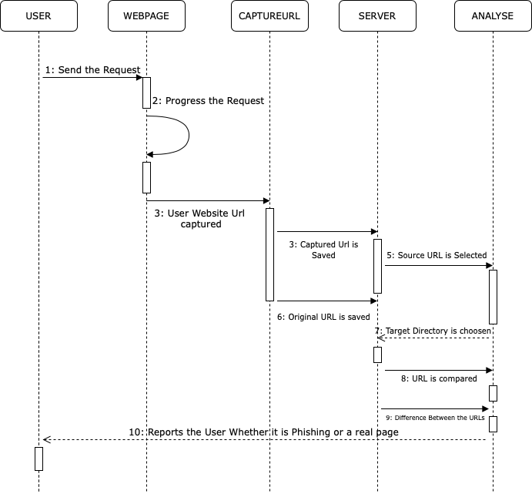

**COLLABORATION DIAGRAM:**

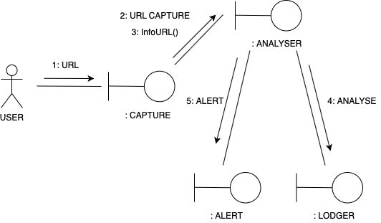

**Reference:**

[**https://www.visual-paradigm.com/guide/uml-unified-modeling-language/what-is-sequence-diagram/**](https://www.visual-paradigm.com/guide/uml-unified-modeling-language/what-is-sequence-diagram/)

[**https://www.visual-paradigm.com/guide/uml-unified-modeling-language/what-is-uml-collaboration-diagram/**](https://www.visual-paradigm.com/guide/uml-unified-modeling-language/what-is-uml-collaboration-diagram/)

[**https://www.lucidchart.com/pages/uml-sequence-diagram**](https://www.lucidchart.com/pages/uml-sequence-diagram)

<https://www.lucidchart.com/pages/uml-communication-diagram>

[**https://www.draw.io/**](https://www.draw.io/)

[**https://creately.com/**](https://creately.com/)

**Conclusion:**

|  |
| --- |
| WITH THE HELP OF THIS EXPERIMENT, WE CAN CREATE SEQUENCE AND COLLABORATION DIAGRAM OF OUR |
| GIVEN PROJECT TOPIC. |